Why Cultures are Different
Based on a lecture by Professor David Burnett
It was a typical hot sunny day in Madras, India as the little taxi hurried through the streets to the church where I was scheduled to speak. I had my wife and one-year-old daughter with me; it was a struggle to get out of the taxi with my daughter in one hand and my Bible in the other. Quickly I reached into my shirt pulling out money to pay the taxi driver. When I handed him the money a look of disgust flashed across his face. Then I realised what I had done—I had handed him the money with my left hand. I apologised and the taxi driver smiled in sympathy at the foreigner who didn’t know any better. I could almost hear him thinking, ‘Why are foreigners so strange?’ Stories such like this are common: they are shared by anyone who has worked in another country for an extended period of time; they illustrate some of the practical problems of interacting with people from another country. In order to understand the basic problem, we should first make clear what we mean by the word culture.

When English speakers think of the word culture they have ideas like music, art, food, literature, and refined behaviour in mind. For social scientists (called cultural anthropologists) culture is the total way of life of a society (including its values, symbols and norms). Every society has a culture. Working in India I quickly realised I had to learn the culture in order to work within it.

1. Culture is Shared
Culture is shared by a group of people. If only one person thinks or acts in a certain way, that thought or action represents a personal habit (not a pattern for an entire culture). For something to be considered cultural, it must be shared by everyone. Cultural anthropologists use the term “in-group” to identify a group of people who relate first and foremost with one another. For example, if a person was born in Canada their in-group is defined as “Canadian” (and they likely share certain specific values and views in common with other Canadians). Yet, this description is a little over-simplified, i.e. there are many sub-groups of Canadians, e.g. French and English. If in-groups exist then certainly “out-groups” exist, as well. Anthropologists use the term “out-group” to refer to people who do not belong to a particular in-group. In my case, I belong to an American in-group while people born in India belong to an out-group I do not belong to; and, members of in-groups, more often than not, share a worldview and belief system in common.
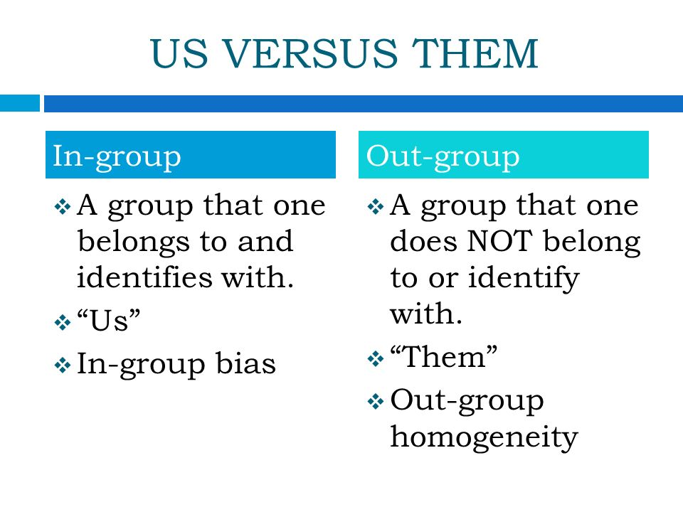

2. Culture is Customs
Culture is rather like the layers of an onion. When one peels off one layer it reveals another, deeper layer. When you live and interact with people from another culture, you immediately notice superficial or obvious differences. For example, when I walk on the streets of Tokyo (Japan) I immediately notice Japanese people refuse to make eye-contact with me; however, if I walk around on the streets of New York City people have absolutely no problem looking me in the eye. The Japanese are often shocked at the loud nose-blowing of the European; it is not considered proper in Japanese society to blow one’s nose in public. By contrast if an Englishman failed to muffle a burp after eating he would embarrass his wife if; however, in much of China a loud belch is considered a polite way of saying “very delicious indeed!”

The above examples represent the “first layer” of the cultural onion. Culture goes much deeper than that. The reason a person in Tokyo does not look another person in the eye is not just a gesture of respect. Culture is also a reflection of a people’s history. In 1868 Tokyo was made the capital city of Japan. The Japanese government was dominated by the samurai (a class of warrior aristocrats). Regular citizens were expected to be completely obedient. Showing obedience meant keeping one’s eye down to the ground when talking to someone—like a samurai—who was their social superior. This custom of deference beginning in the middle of the 19th century continues to shape how Japanese people in Tokyo interact with one another in the 21st century. So, in order to understand the nature of culture, students need to appreciate customs develop over time and reflect the everyday values of the people who adhere to them.

3. Culture is Language
Language is an important feature of any culture because it allows the people of an in-group to communicate with one another. Learning a language is an important part of being able to relate to people of a particular culture. Yet learning another language is not as simple as just finding the Maori equivalent (“kuri”) for the English word “dog.” Words taken together can actually mean more than what they literally say. For example, if an English speaker said they want to “kill two birds with one stone” they are not literally talking about killing birds; instead, the speaker is saying they plan on completing more than one job with a single action. This is an example of idiom.

All cultures have their unique idioms and expressions. These expressions carry specific meaning for their users (members of the in-group). Idioms do not make obvious sense to members of an out-group because they are culturally specific. For example, an Englishman speaking to an Indian person said, “I will pick you up at six o’clock.” The Indian person was left wondering why the man wanted to lift him up from the ground, and especially why he wanted to do this specifically at six p.m.

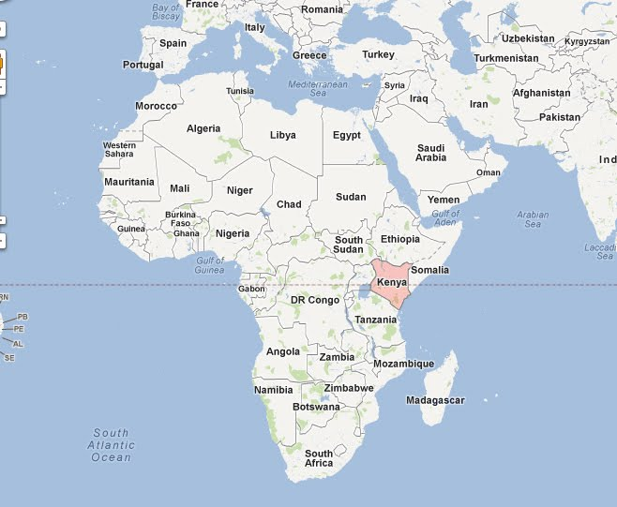
Culture-specific idioms can often lead to misunderstandings. A man I know named Elijah was driving in Nairobi, Kenya. He had a minor accident in a parking lot. The accident delayed him from getting home on time. Elijah knew his family would be worried so he asked someone to phone his wife and explain the delay. When he arrived home an hour or so later he found his wife mourning his death. She thought he had been killed in the accident. This is because when she asked the messenger if her husband was there she was told no. Apparently, in the language of the Kikuyu the question “Is he there?” actually asks “Is he alive?” Since she was told “no” she assumed her husband was dead. Interestingly, the entire phone conversation took place in English. Yet, Elijah’s wife was literally thinking in Kikuyu.

If communicating something as simple as “I was in an accident and I am going to be late” is so liable to be misunderstood, communicating something more complicated is even more likely to cause confusion.

4. Culture is Values and Ideas
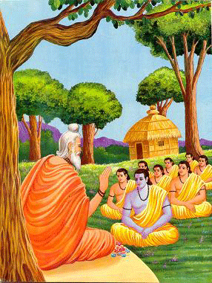
Customs are the practical expression of a culture; they reflect the values of a people through a country’s institutions like marriage, law, education, religious rituals, economics and art. These reveal something about the deeper layer of the onion. This is because at the deepest level of any culture is a set of basic ideas shared by the community; these ideas are absolutely foundational to a culture’s whole way of life. These foundational ideas are collectively referred to as the worldview of a people. The people who prescribe (or believe in) a particular worldview usually just assume their ideas are so obviously true no member of their society in their right mind would ever think of questioning them. For example, Western cultures—Canada, America, France, Germany, England, Italy, and Greece—emphasizes the need for physical proof before believing in something; however, in classical Indian philosophy the complete opposite is true: the physical world is an illusion and the world of ideas is real. This explains why an Indian guru (teacher) spends so much time meditating whereas Westerners tend to focus on the material (physical) world.

Interestingly, members of an in-group may or may not actually be conscious their beliefs and values are just part of one of countless unique worldviews. Instead, every in-group usually just assumes their beliefs are the right ones, their values are the correct ones, and other cultures are somehow “off” or in error. In all honesty, there is no single correct or right worldview (or at least no way to measure something like this with anything resembling confidence or accuracy). The fact is there are as many worldviews as there are individual cultures on the earth (numbering in the thousands).

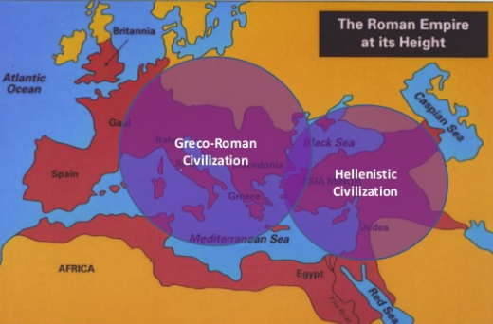
Western people find satisfaction in the idea of order and certainty in daily life. Westerners value clarity of thought as a sign of intelligence. This is a product of the West’s Greco-Roman heritage. Again, for Westerners ideas must be precise and classified. By contrast, the Baoule of the Ivory Coast strive for unity rather than analysis. Unlike Westerners who feel it is necessary to divide reality into smaller and smaller bits in order to understand it (as in the science of physics, chemistry and biology), the Baoule hate to break up things; they want to maintain a worldview where the physical and supernatural world are unified.

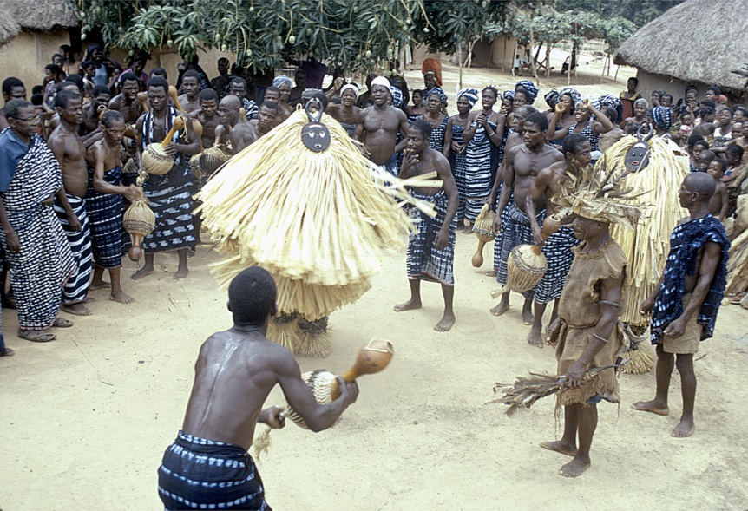
During a class on sex education geared to illiterate Baoule, male and female physiology was explained and diagrams and pictures were used to show the development of the foetus. It was all very clear, but at the end of the session the people went away saying: “We saw a lot of things, but that is not the way one has children; there is something invisible behind all that, and that is where truth is to be found.” It is at this level that religious ideas are of great importance. The Westerner may have great difficulty with a lack of proof God exists, but most societies consider its existence is so obvious as to be unquestionable.

Many African societies believe in the existence of a supreme creator; they do wonder though why the creator has withdrawn from them. The Westerner would argue God never withdrew, he simply never existed in the first place; nevertheless, to the African the world is dominated by lesser gods and spirits who must be kept happy. Thus, sickness is considered the result of affliction by one of these spiritual beings who want to harm a person for some reason. A Western doctor who identifies the physical causes of a disease does not satisfy a member of the Baoule with such an explanation. The doctor might explain the malaria was caused by a mosquito bite. Yet, the Baoule person would ask a follow-up question to what caused the disease, e.g. Who sent the mosquito though? Surely, someone must have wanted to cause the person to become ill. According to the Baoule things always happened for a reason whereas a Westerner is perfectly capable of accepting the possibility that sometimes things just happen.

5. Culture is Learnt
How is it that the English behave in one way, the Chinese in another, and the Arabs in yet another? Culture is not passed on by genes from one generation to another. Rather, culture is transmitted from generation to generation to generation. Sleeping or eating is not cultural but instinctual. But when and where to sleep and how and what to eat are learned activities.

The process of learning a culture begins at birth and continues throughout one’s adult life. Gradually, patterns and ideas learned at an early age become the basis of one’s beliefs, values and actions. These patterns and ideas form the basis of a parent culture. The parent culture is something parents and children alike inherit and unconsciously pass on from generation to generation. Differences in various parent cultures make them distinct from one another. For example, a nomad from the semi-arid Sahel will pass on to his children the skills of looking after their cattle. He will show them how to find good grazing, and to breed the stock. A farmer will pass on to his children the skills of growing crops.

The cultural heritage of a people is handed down by the process of subconscious learning. Because most of us are brought up within only one culture we tend to be ignorant of the fact that there are other ways of living. We assume that because we have been brought up to follow certain patterns these must be the best. An Englishman trying to eat with chopsticks for the first time may quickly come to the conclusion it is better to eat with a knife and fork; and a Chinese lady eating with a knife and fork for the first time concludes chopsticks are far better. Even though both people could, with practice, learn to effectively use either a knife/fork or chopsticks; however, it is easy, even natural, to conclude one’s ways are better than those of others. This attitude is found in all societies, and is known as ethnocentrism (or more simply cultural pride).

